select * from students10;

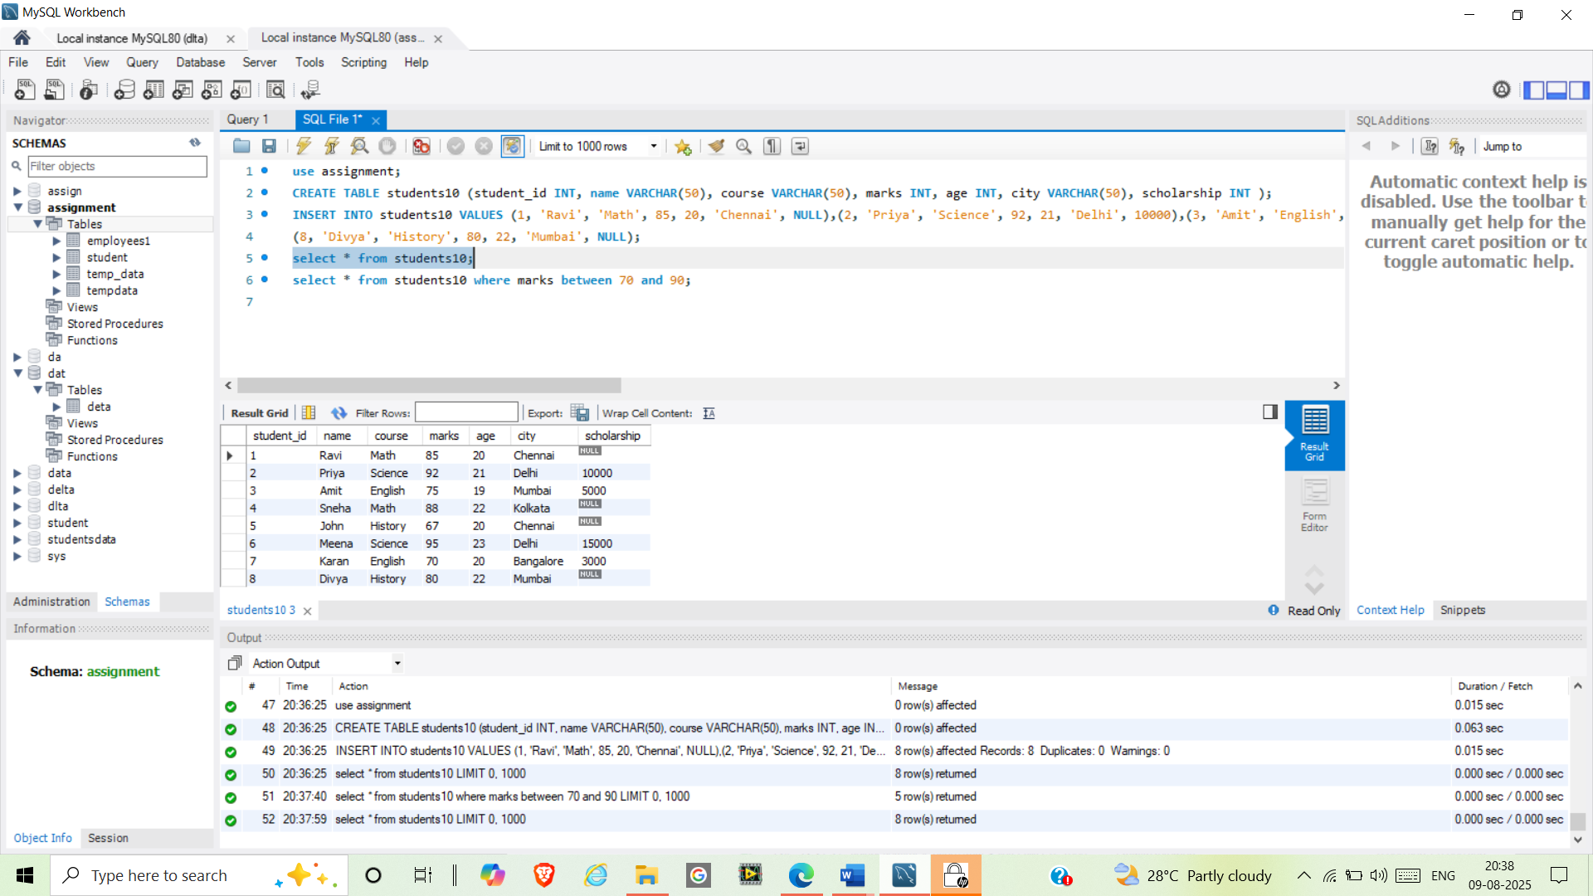

select * from students10 where marks between 70 and 90;

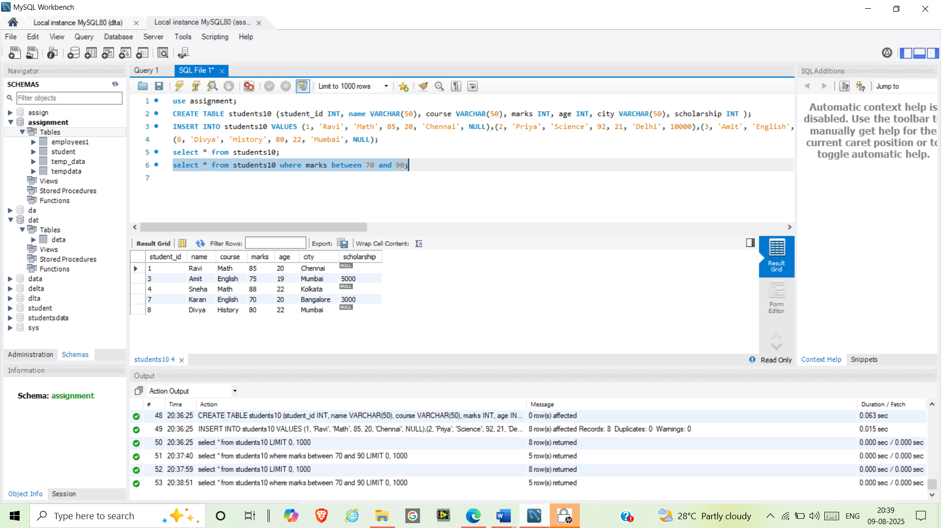

select * from students10 where age between 20 and 22;

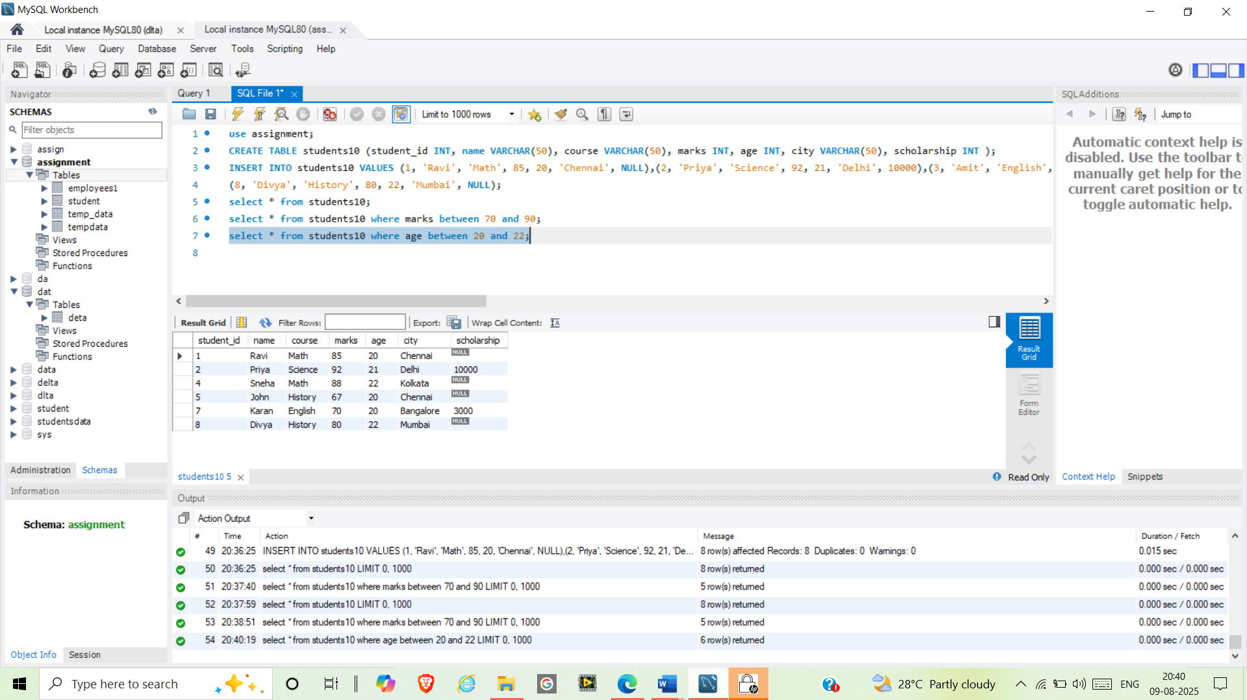

select * from students10 where name like("P%");

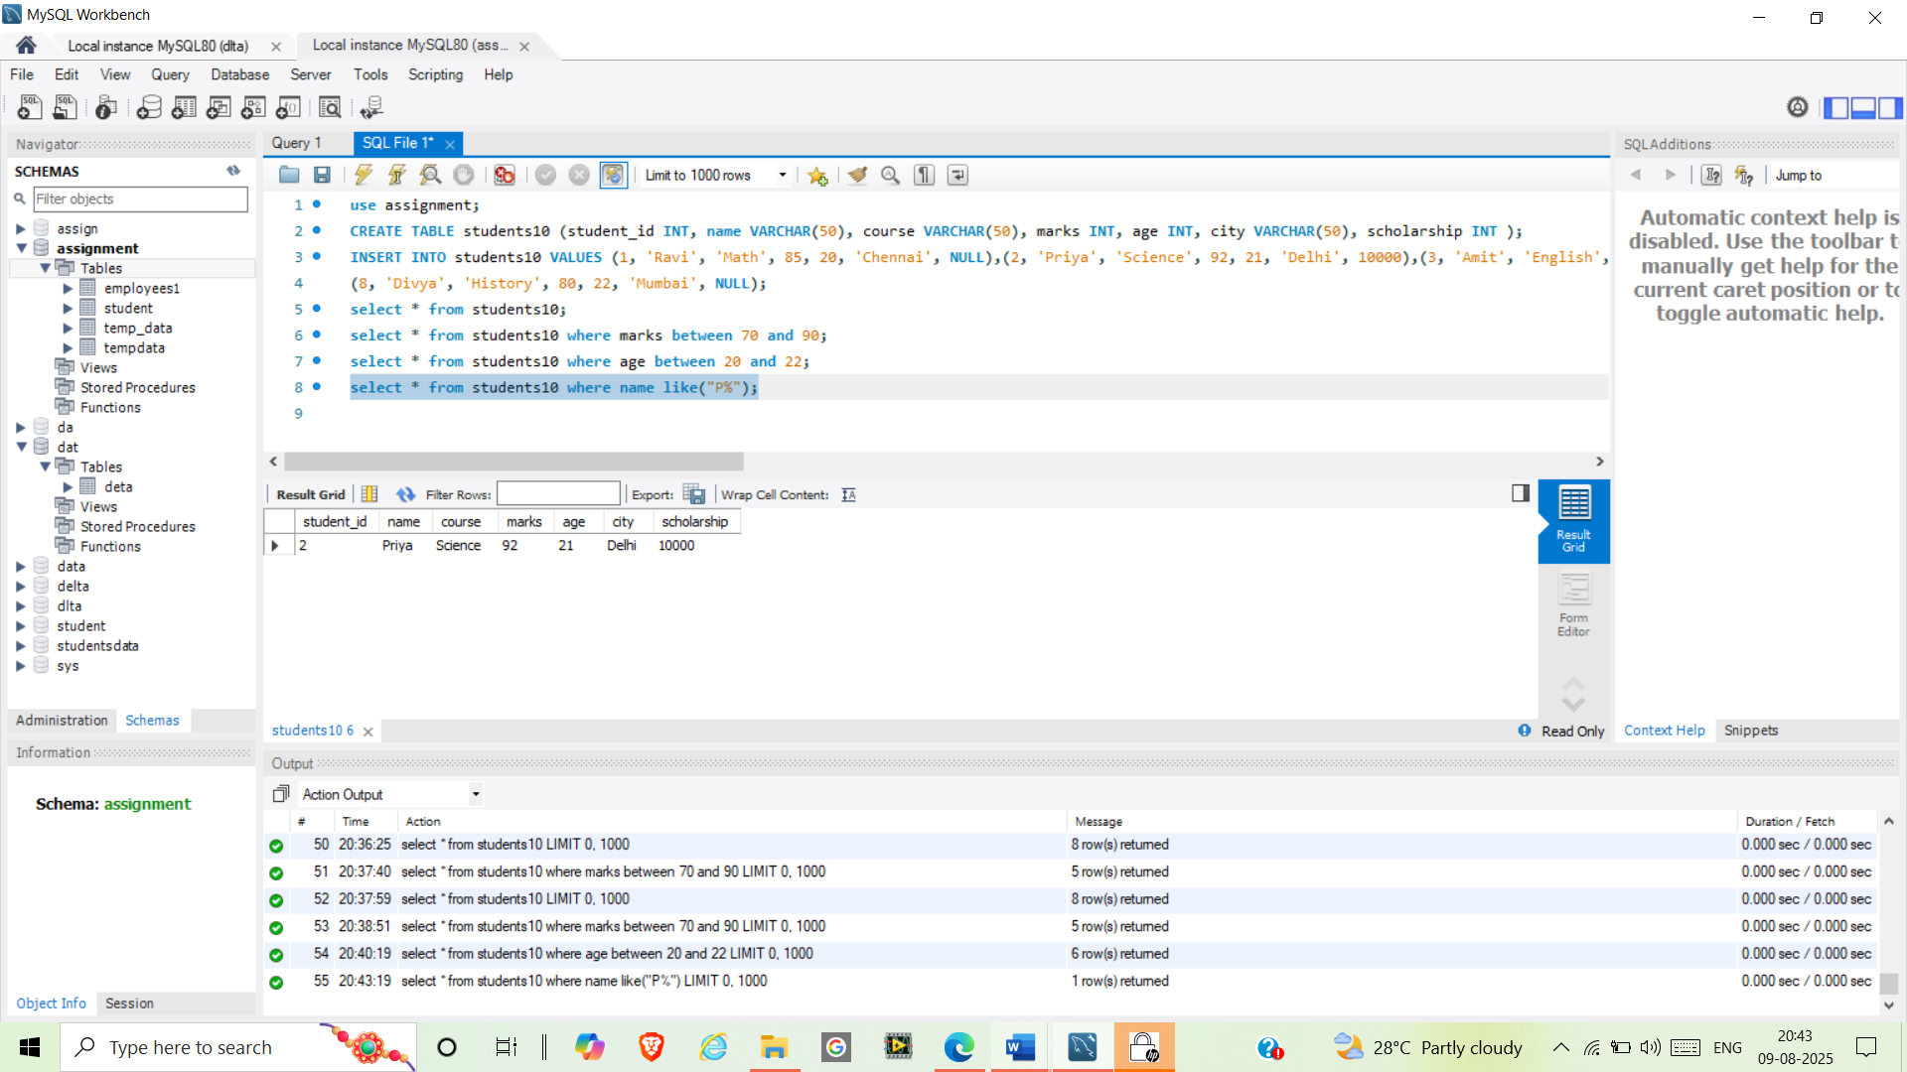

select * from students10 where name like("%ai%");

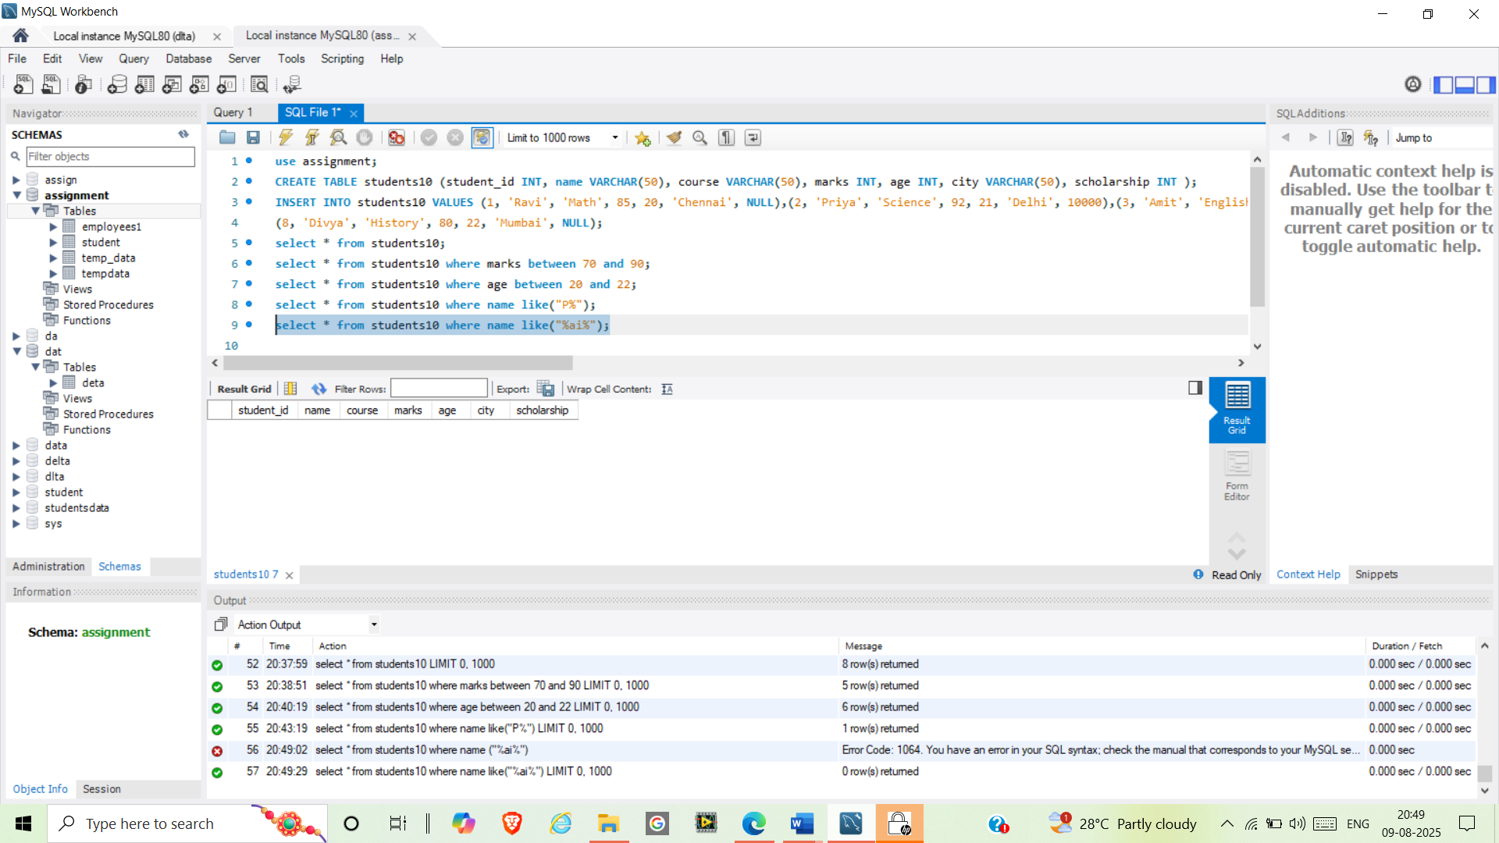

select * from students10 where course='Math' and marks>21;

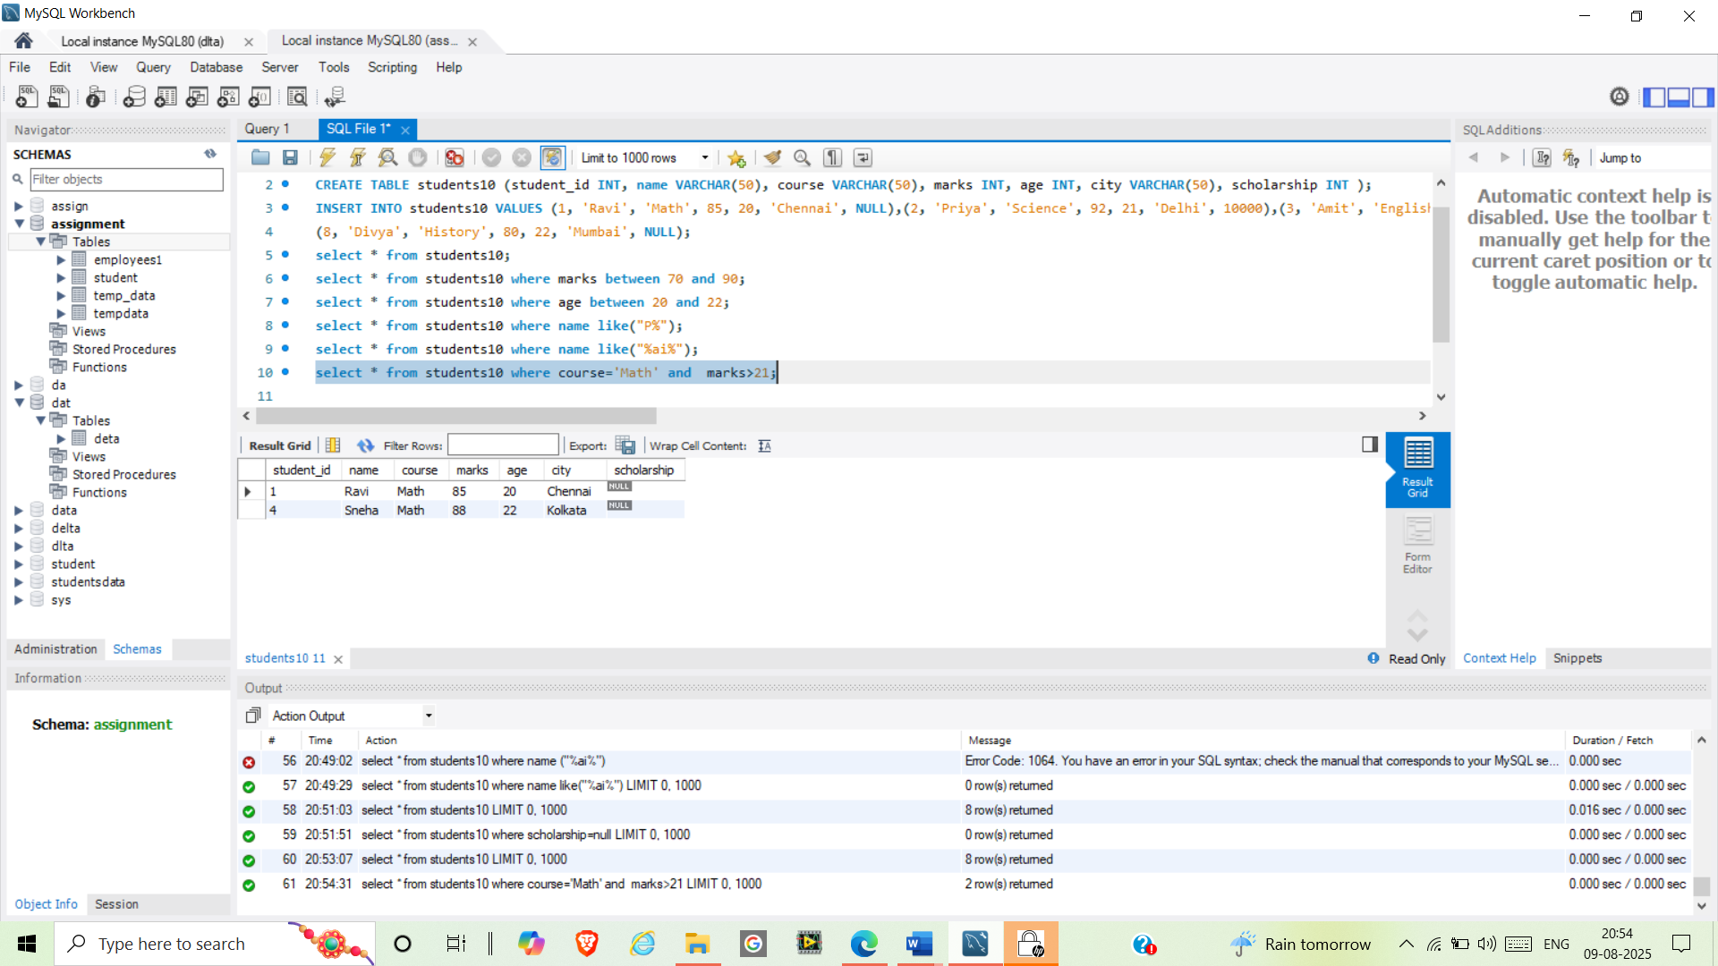

select * from students10 where course='Science' or course='English';

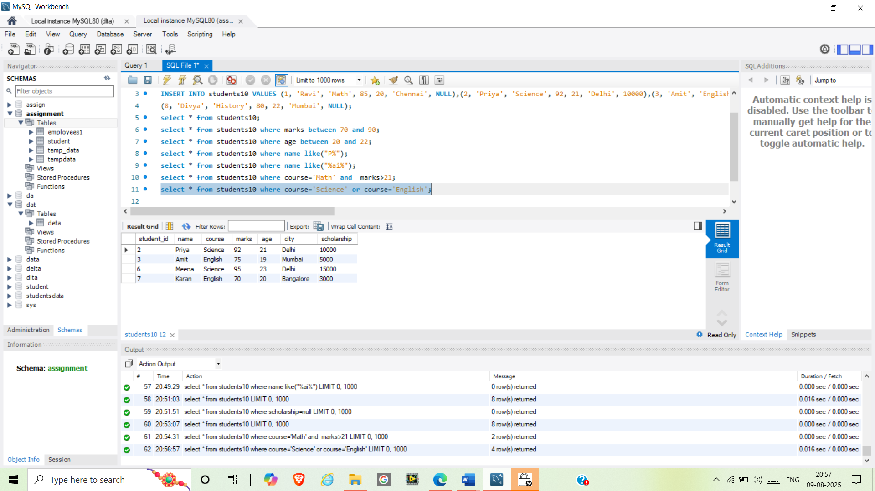

select ifnull(scholarship,0) from students10;

select coalesce(scholarship,0) from students10;

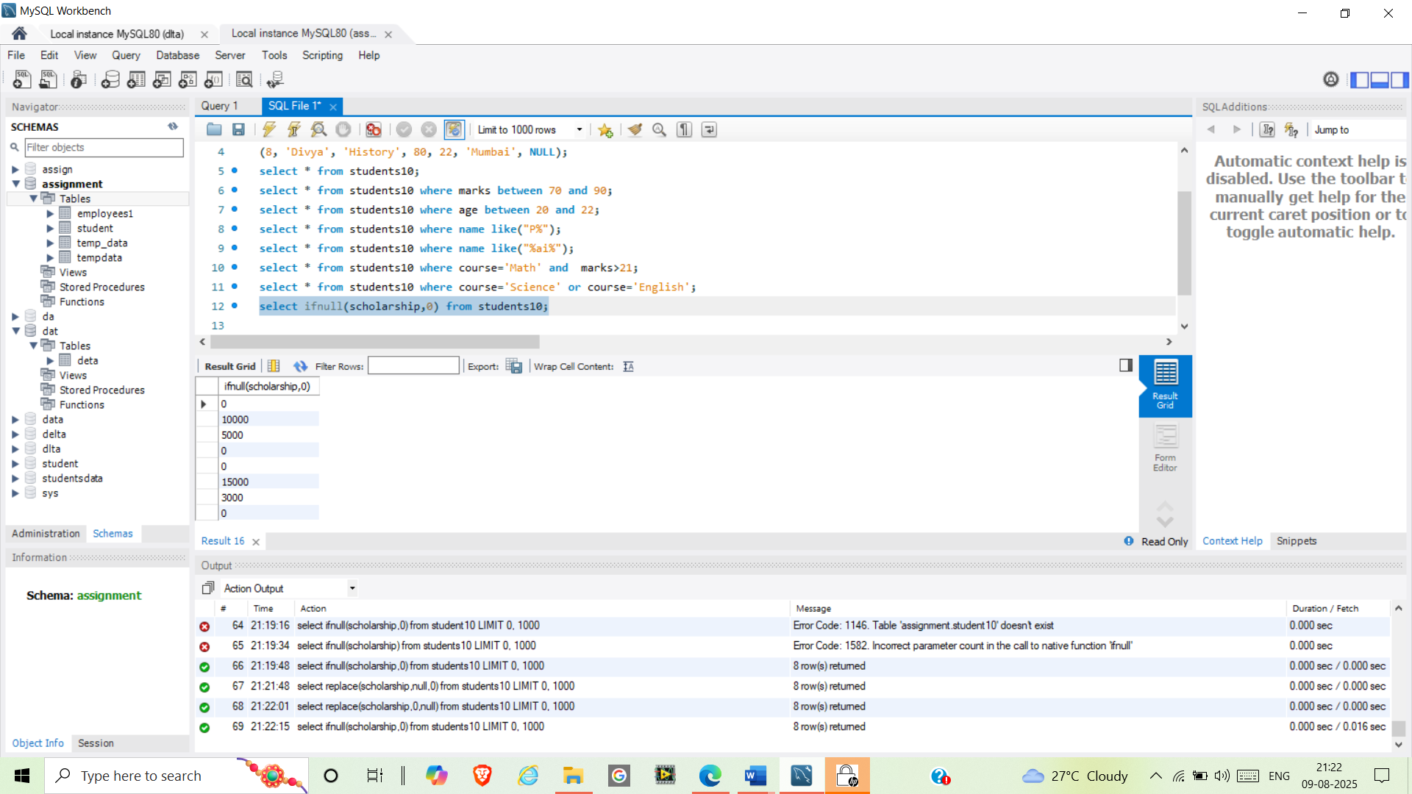

select * from students10 where name like("_r%");

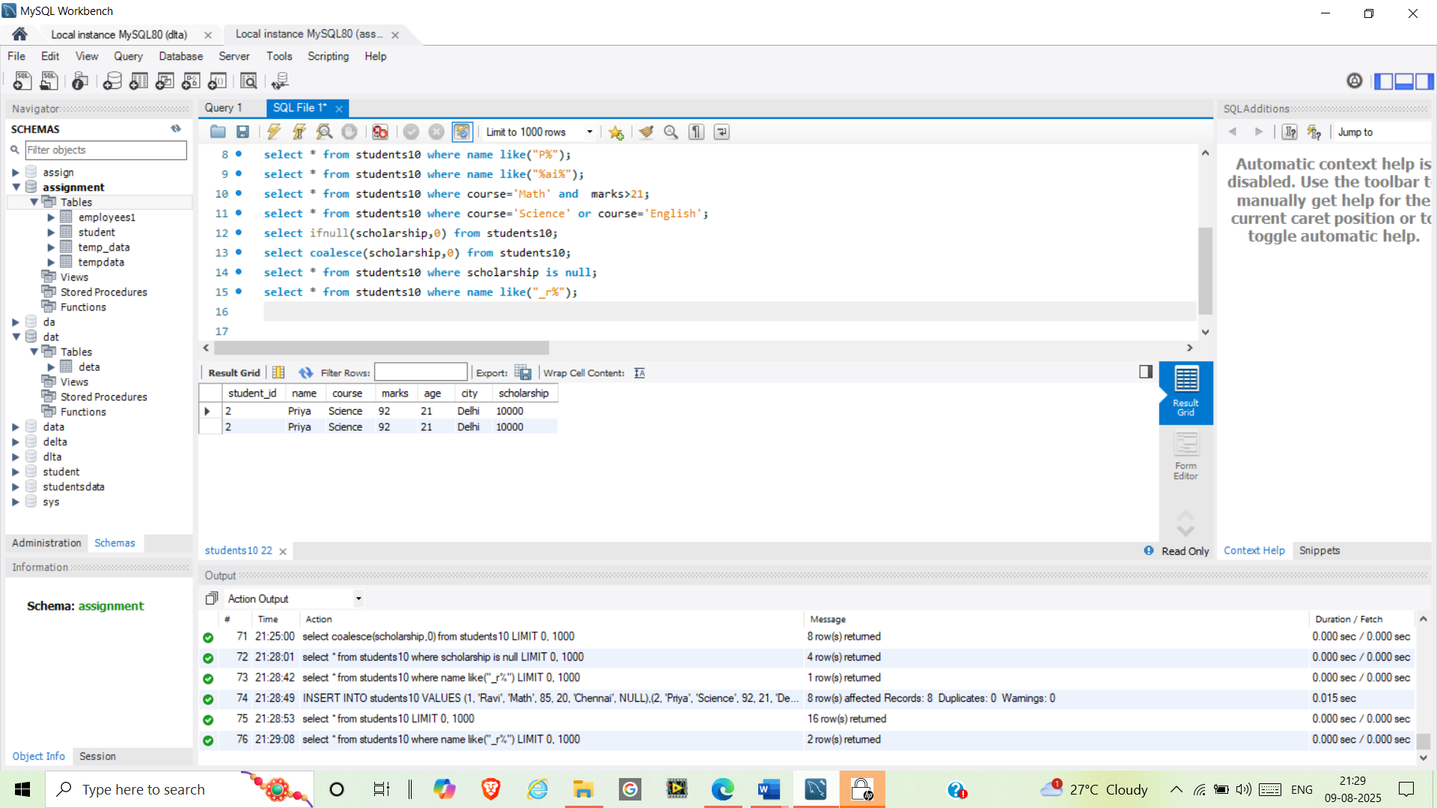

select * from students10 where scholarship is null;

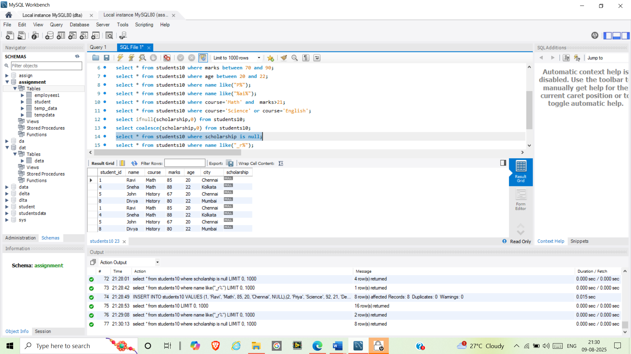

select * from students10 where scholarship is not null;

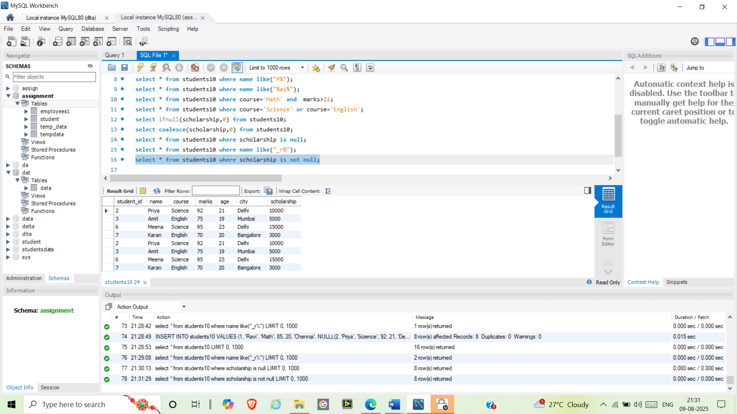

select * from students10 where not city='Mumbai';

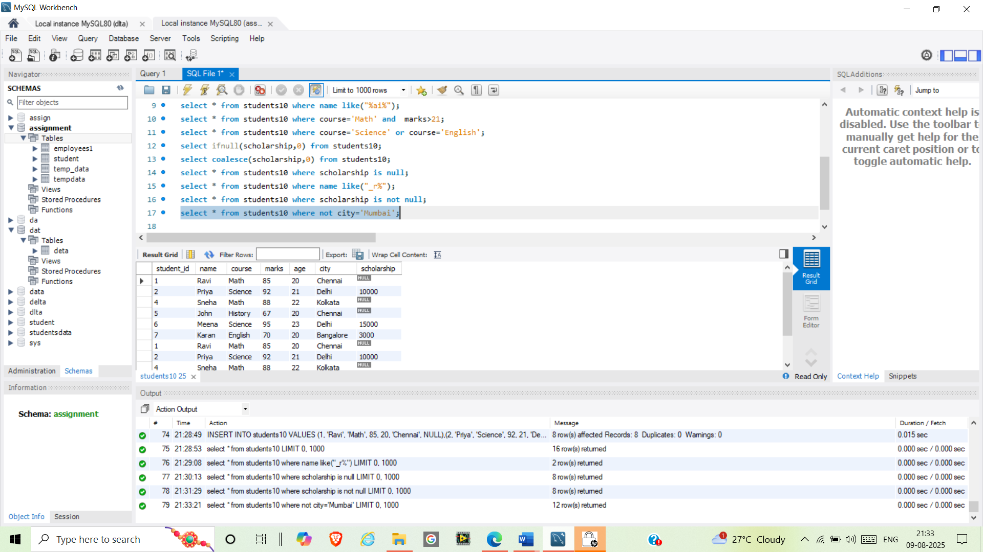

select * from students10 where marks>all(select marks from students10 where course='English');

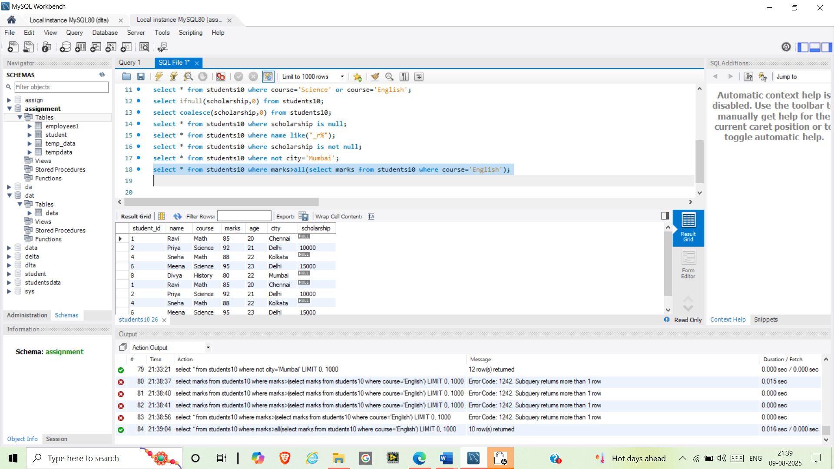

select * from students10 where marks>any(select marks from students10 where course='History');

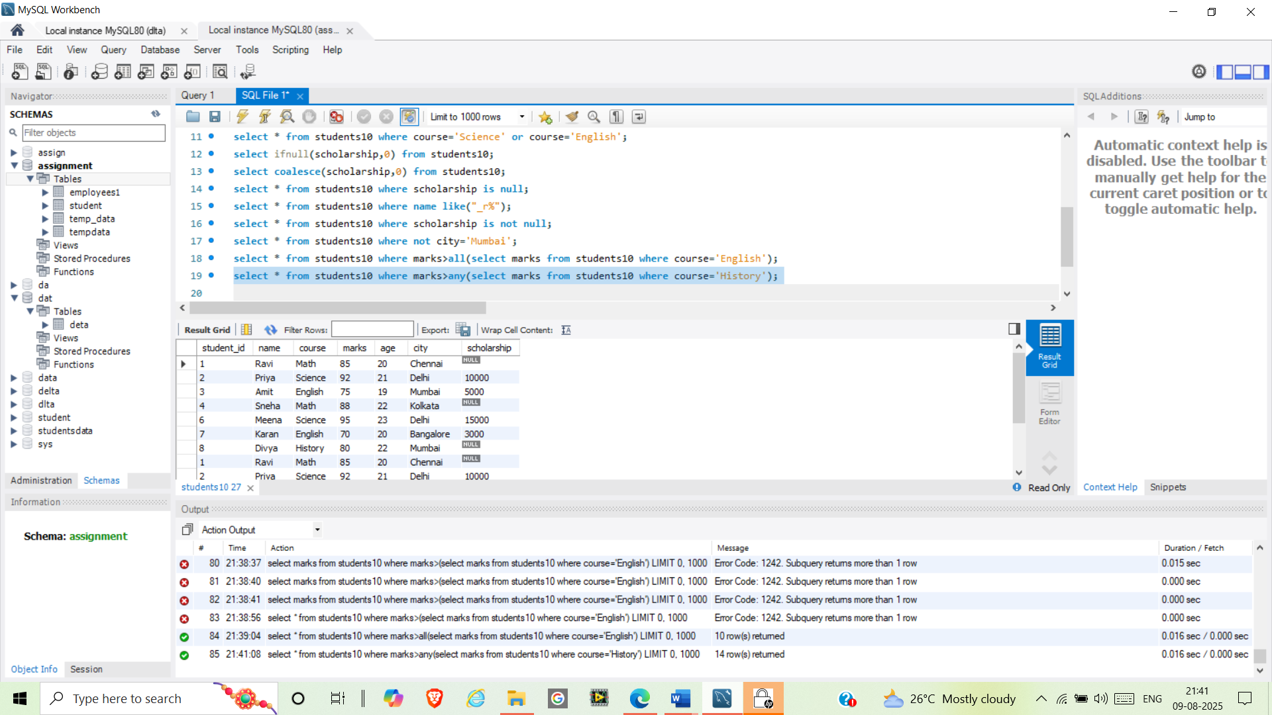

select *from students10 order by marks desc limit 3

